Trapezoidal-Base Pyramid
# Source: AI Source: Provided by: [Data Path: Persons Table -> ID Column: 1, Name_En Column: Motasem Essam] -> From: [ChatGPT] on [7/25/2026]
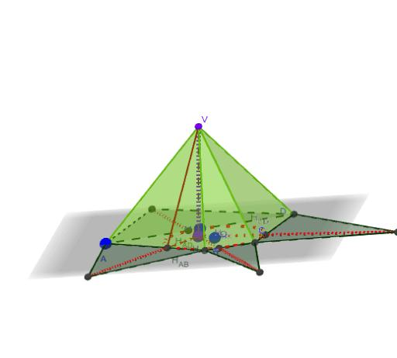
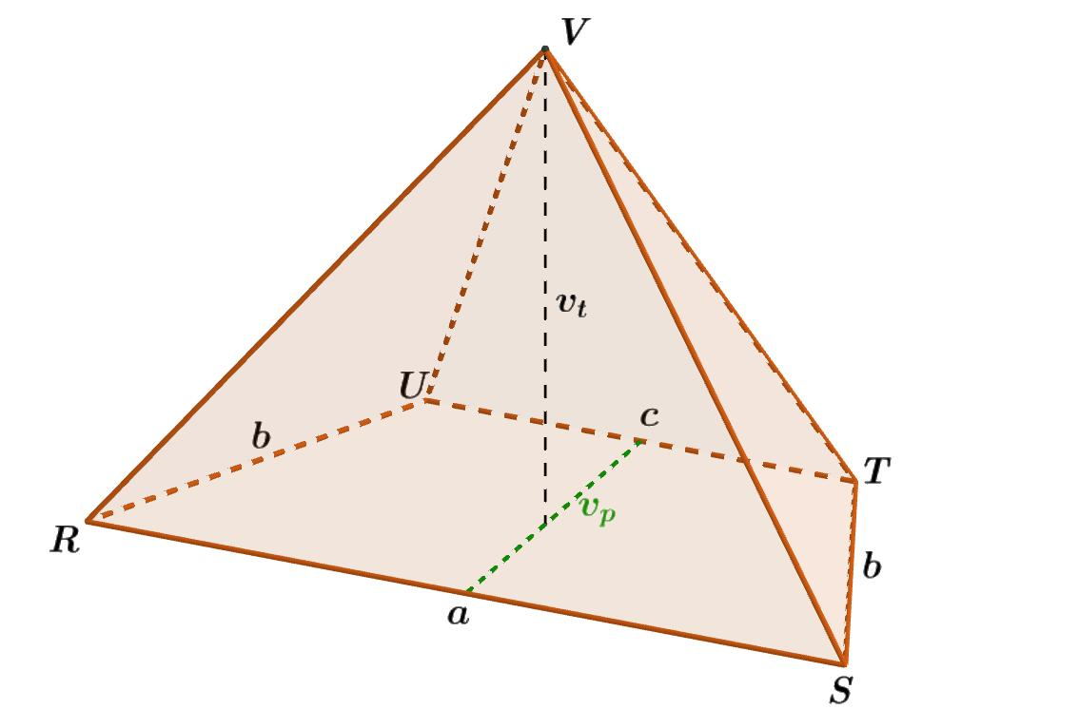
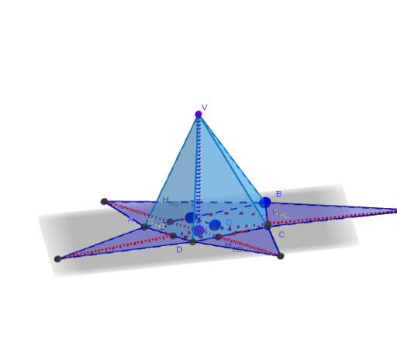

Definition
# Source: AI Source: Provided by: [Data Path: Persons Table -> ID Column: 1, Name_En Column: Motasem Essam] -> From: [ChatGPT] on [7/25/2026]
A trapezoidal-base pyramid is a three-dimensional geometric solid whose base is a trapezoid and whose lateral faces are four triangles that meet at a single point called the apex.
A trapezoid is a quadrilateral with at least one pair of parallel sides under the inclusive mathematical convention. Some textbooks use the exclusive convention, requiring exactly one pair of parallel sides. The convention used should be stated when classifying trapezoids.
A trapezoidal-base pyramid has:
- 1 trapezoidal base.
- 4 triangular lateral faces.
- 5 faces in total.
- 8 edges in total.
- 5 vertices in total.
The pyramid can be right or oblique, depending on the position of the apex relative to the designated center of the base.

Simple Definition
# Source: AI Source: Provided by: [Data Path: Persons Table -> ID Column: 1, Name_En Column: Motasem Essam] -> From: [ChatGPT] on [7/25/2026]
A trapezoidal-base pyramid is a pyramid with a trapezoid as its base and four triangular sides that meet at one top point.

Key Characteristics
# Source: AI Source: Provided by: [Data Path: Persons Table -> ID Column: 1, Name_En Column: Motasem Essam] -> From: [ChatGPT] on [7/25/2026]
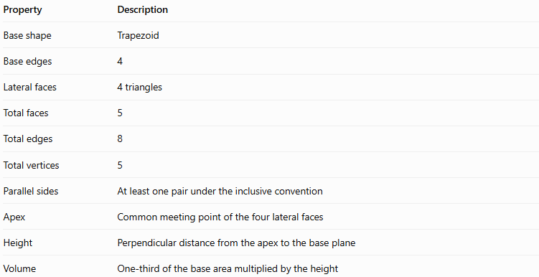
Property | Description
Base shape | Trapezoid
Base edges | 4
Lateral faces | 4 triangles
Total faces | 5
Total edges | 8
Total vertices | 5
Parallel sides | At least one pair under the inclusive convention
Apex | Common meeting point of the four lateral faces
Height | Perpendicular distance from the apex to the base plane
Volume | One-third of the base area multiplied by the height

Geometric Representation
# Source: AI Source: Provided by: [Data Path: Persons Table -> ID Column: 1, Name_En Column: Motasem Essam] -> From: [ChatGPT] on [7/25/2026]
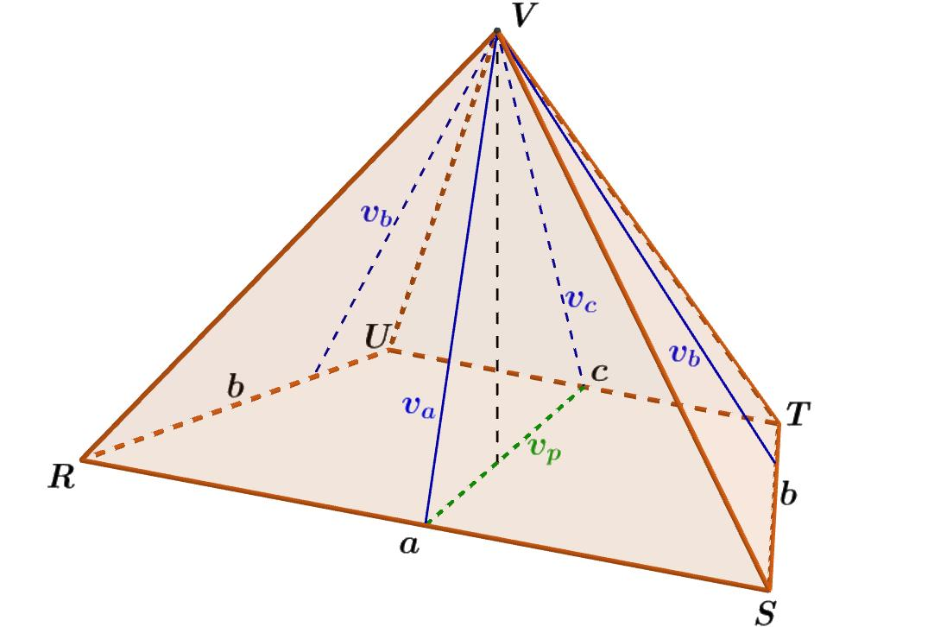
The main components are:
- Base: The trapezoid at the bottom of the pyramid.
- Lateral faces: Four triangular surfaces connecting the base edges to the apex.
- Base edges: The four sides of the trapezoid, including its parallel sides.
- Lateral edges: Four line segments connecting the apex to the four base vertices.
- Apex: The point where all four lateral faces meet.
- Height: The perpendicular distance from the apex to the plane containing the trapezoid base.
The four triangular faces do not necessarily have equal areas or congruent shapes. Their dimensions depend on the trapezoid's side lengths and the position of the apex.

Mathematical Representations and Formulas
# Source: AI Source: Provided by: [Data Path: Persons Table -> ID Column: 1, Name_En Column: Motasem Essam] -> From: [ChatGPT] on [7/25/2026]
Let:
- $a$ and $b$ be the lengths of the parallel sides of the trapezoid.
- $h_{b}$ be the perpendicular distance between the parallel sides.
- $c$ and $d$ be the lengths of the other two sides.
- $H$ be the perpendicular height of the pyramid.
- $B$ be the area of the base.
- $P$ be the perimeter of the base.

Base Area
# Source: AI Source: Provided by: [Data Path: Persons Table -> ID Column: 1, Name_En Column: Motasem Essam] -> From: [ChatGPT] on [7/25/2026]
The area of a trapezoid is half the sum of its parallel sides multiplied by the perpendicular distance between them.
$$\boxed{B=\frac{1}{2}\left(a+b\right)h_{b}}$$

Base Perimeter
# Source: AI Source: Provided by: [Data Path: Persons Table -> ID Column: 1, Name_En Column: Motasem Essam] -> From: [ChatGPT] on [7/25/2026]
The perimeter is the sum of all four sides:
$$\boxed{P=a+b+c+d}$$

Volume
# Source: AI Source: Provided by: [Data Path: Persons Table -> ID Column: 1, Name_En Column: Motasem Essam] -> From: [ChatGPT] on [7/25/2026]
The volume of any pyramid is one-third of its base area multiplied by its perpendicular height.
$$V=\frac{1}{3}BH$$
Substituting the trapezoid's area formula:
$$\boxed{V=\frac{1}{6}\left(a+b\right)h_{b}H}$$
Remember that $h_{b}$ is the height of the trapezoid, whereas $H$ is the height of the pyramid. They describe different distances.

Lateral Surface Area
# Source: AI Source: Provided by: [Data Path: Persons Table -> ID Column: 1, Name_En Column: Motasem Essam] -> From: [ChatGPT] on [7/25/2026]
The lateral surface area is the sum of the four triangular face areas:
$$A_{L}=A_{1}+A_{2}+A_{3}+A_{4}$$
For each triangular face:
$$A_{i}=\frac{1}{2}s_{i}l_{i}$$
where:
- $s_{i}$ is the corresponding trapezoid edge length.
- $l_{i}$ is the perpendicular altitude of that triangular face, measured in the plane of the face.
Therefore:
$$\boxed{A_{L}=\frac{1}{2}\sum_{i=1}^{4}{s_{i}}l_{i}}$$
For an irregular or oblique trapezoidal-base pyramid, calculate each face separately. Do not assume that all four triangular faces have the same slant height.

Total Surface Area
# Source: AI Source: Provided by: [Data Path: Persons Table -> ID Column: 1, Name_En Column: Motasem Essam] -> From: [ChatGPT] on [7/25/2026]
The total surface area includes the base and the four lateral faces:
$$\boxed{A_{T}=B+A_{L}}$$
Or, using the trapezoid's base area:
$$A_{T}=\frac{1}{2}\left(a+b\right)h_{b}+A_{L}$$

Euler’s Formula
# Source: AI Source: Provided by: [Data Path: Persons Table -> ID Column: 1, Name_En Column: Motasem Essam] -> From: [ChatGPT] on [7/25/2026]
For a convex trapezoidal-base pyramid:
$$V_{e}-E+F=2$$
Substituting the counts:
$$5-8+5=2$$
Thus, the pyramid satisfies Euler’s formula for convex polyhedra.

Worked Examples
# Source: AI Source: Provided by: [Data Path: Persons Table -> ID Column: 1, Name_En Column: Motasem Essam] -> From: [ChatGPT] on [7/25/2026]
Example 1: Finding the Base Area
A trapezoidal base has parallel sides of $10\text{ cm}$ and $6\text{ cm}$, with a perpendicular distance of $4\text{ cm}$. Find its area.
Using:
$$B=\frac{1}{2}\left(a+b\right)h_{b}$$
Substitute the values:
$$B=\frac{1}{2}\left(10+6\right)\left(4\right)$$
$$B=\frac{1}{2}\left(16\right)\left(4\right)$$
$$\boxed{B=32{\text{ cm}}^{2}}$$
Example 2: Finding the Volume
A trapezoidal-base pyramid has a base area of $32{\text{ cm}}^{2}$ and a perpendicular height of $9\text{ cm}$. Find its volume.
Using:
$$V=\frac{1}{3}BH$$
$$V=\frac{1}{3}\left(32\right)\left(9\right)$$
$$\boxed{V=96{\text{ cm}}^{3}}$$
Example 3: Finding the Base Perimeter
A trapezoid has side lengths of $10\text{ cm}$, $6\text{ cm}$, $5\text{ cm}$, and $5\text{ cm}$. Find its perimeter.
$$P=a+b+c+d$$
$$P=10+6+5+5$$
$$\boxed{P=26\text{ cm}}$$
Example 4: Finding the Number of Faces, Edges, and Vertices
A trapezoidal-base pyramid has a four-sided base, so $n=4$.
For a pyramid with an $n$-sided base:
$$F=n+1, E=2n, V_{e}=n+1$$
Therefore:
$$F=5, E=8, V_{e}=5$$
Answer: 5 faces, 8 edges, and 5 vertices.

Comparison with Related Pyramids
# Source: AI Source: Provided by: [Data Path: Persons Table -> ID Column: 1, Name_En Column: Motasem Essam] -> From: [ChatGPT] on [7/25/2026]
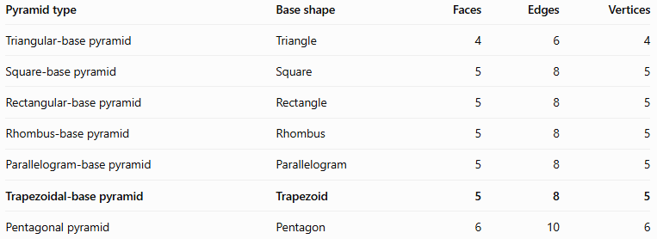
Pyramid type | Base shape | Faces | Edges | Vertices
Triangular-base pyramid | Triangle | 4 | 6 | 4
Square-base pyramid | Square | 5 | 8 | 5
Rectangular-base pyramid | Rectangle | 5 | 8 | 5
Rhombus-base pyramid | Rhombus | 5 | 8 | 5
Parallelogram-base pyramid | Parallelogram | 5 | 8 | 5
Trapezoidal-base pyramid | Trapezoid | 5 | 8 | 5
Pentagonal pyramid | Pentagon | 6 | 10 | 6
All quadrilateral pyramids have the same number of faces, edges, and vertices. Their main difference is the shape of their base.
Under the inclusive convention, a parallelogram is also a trapezoid because it has at least one pair of parallel sides. Under the exclusive convention, a trapezoid has exactly one pair, so parallelograms are excluded.

Constructing Trapezoidal-Base Pyramid in Solid Geometry

Instruments Used
# Source: AI Source: Provided by: [Data Path: Persons Table -> ID Column: 1, Name_En Column: Motasem Essam] -> From: [ChatGPT] on [7/25/2026]
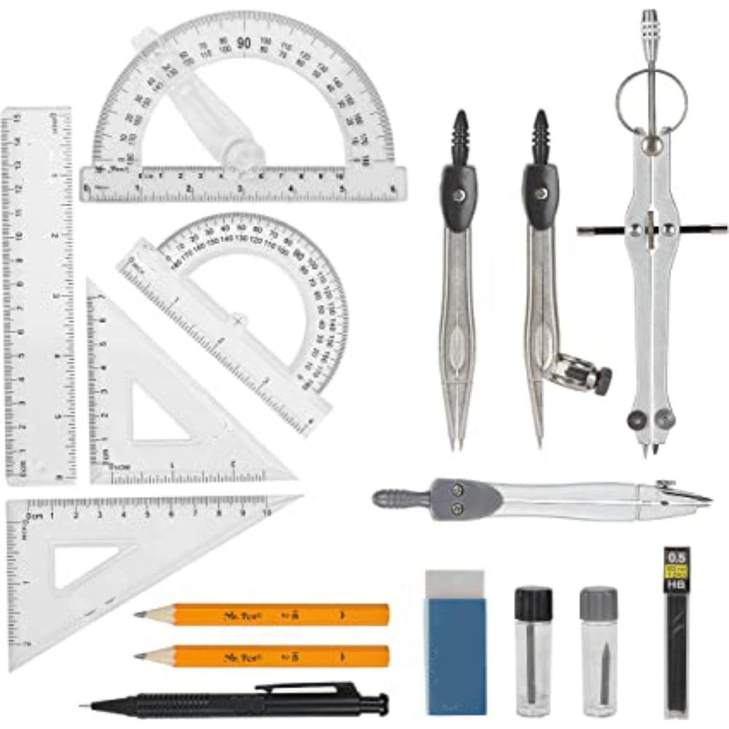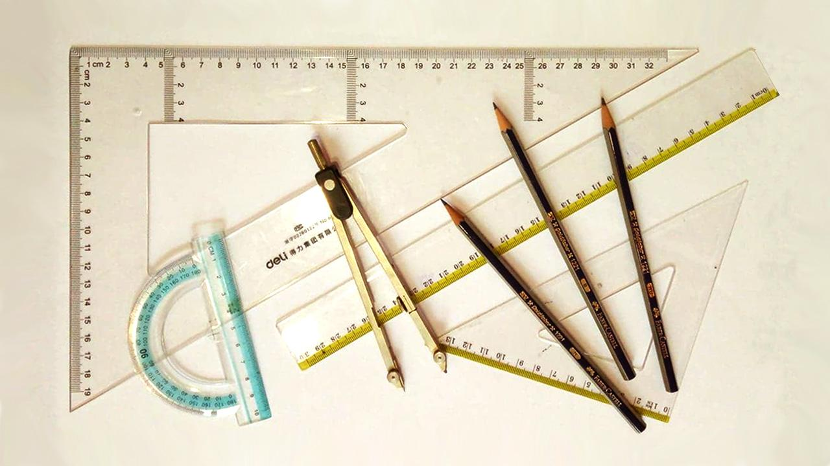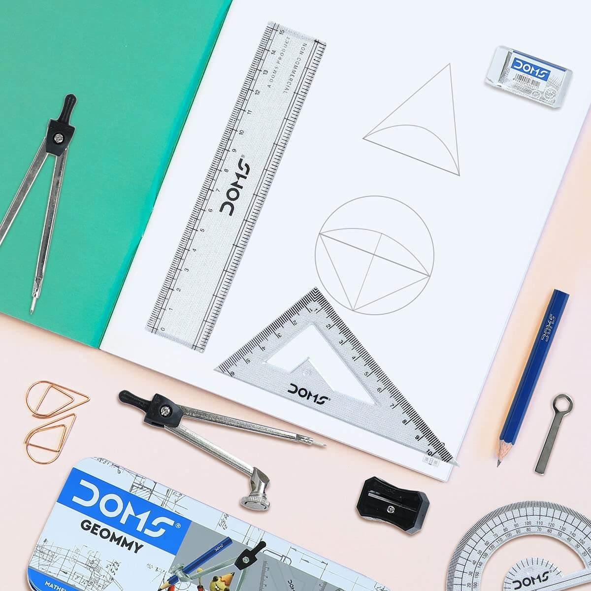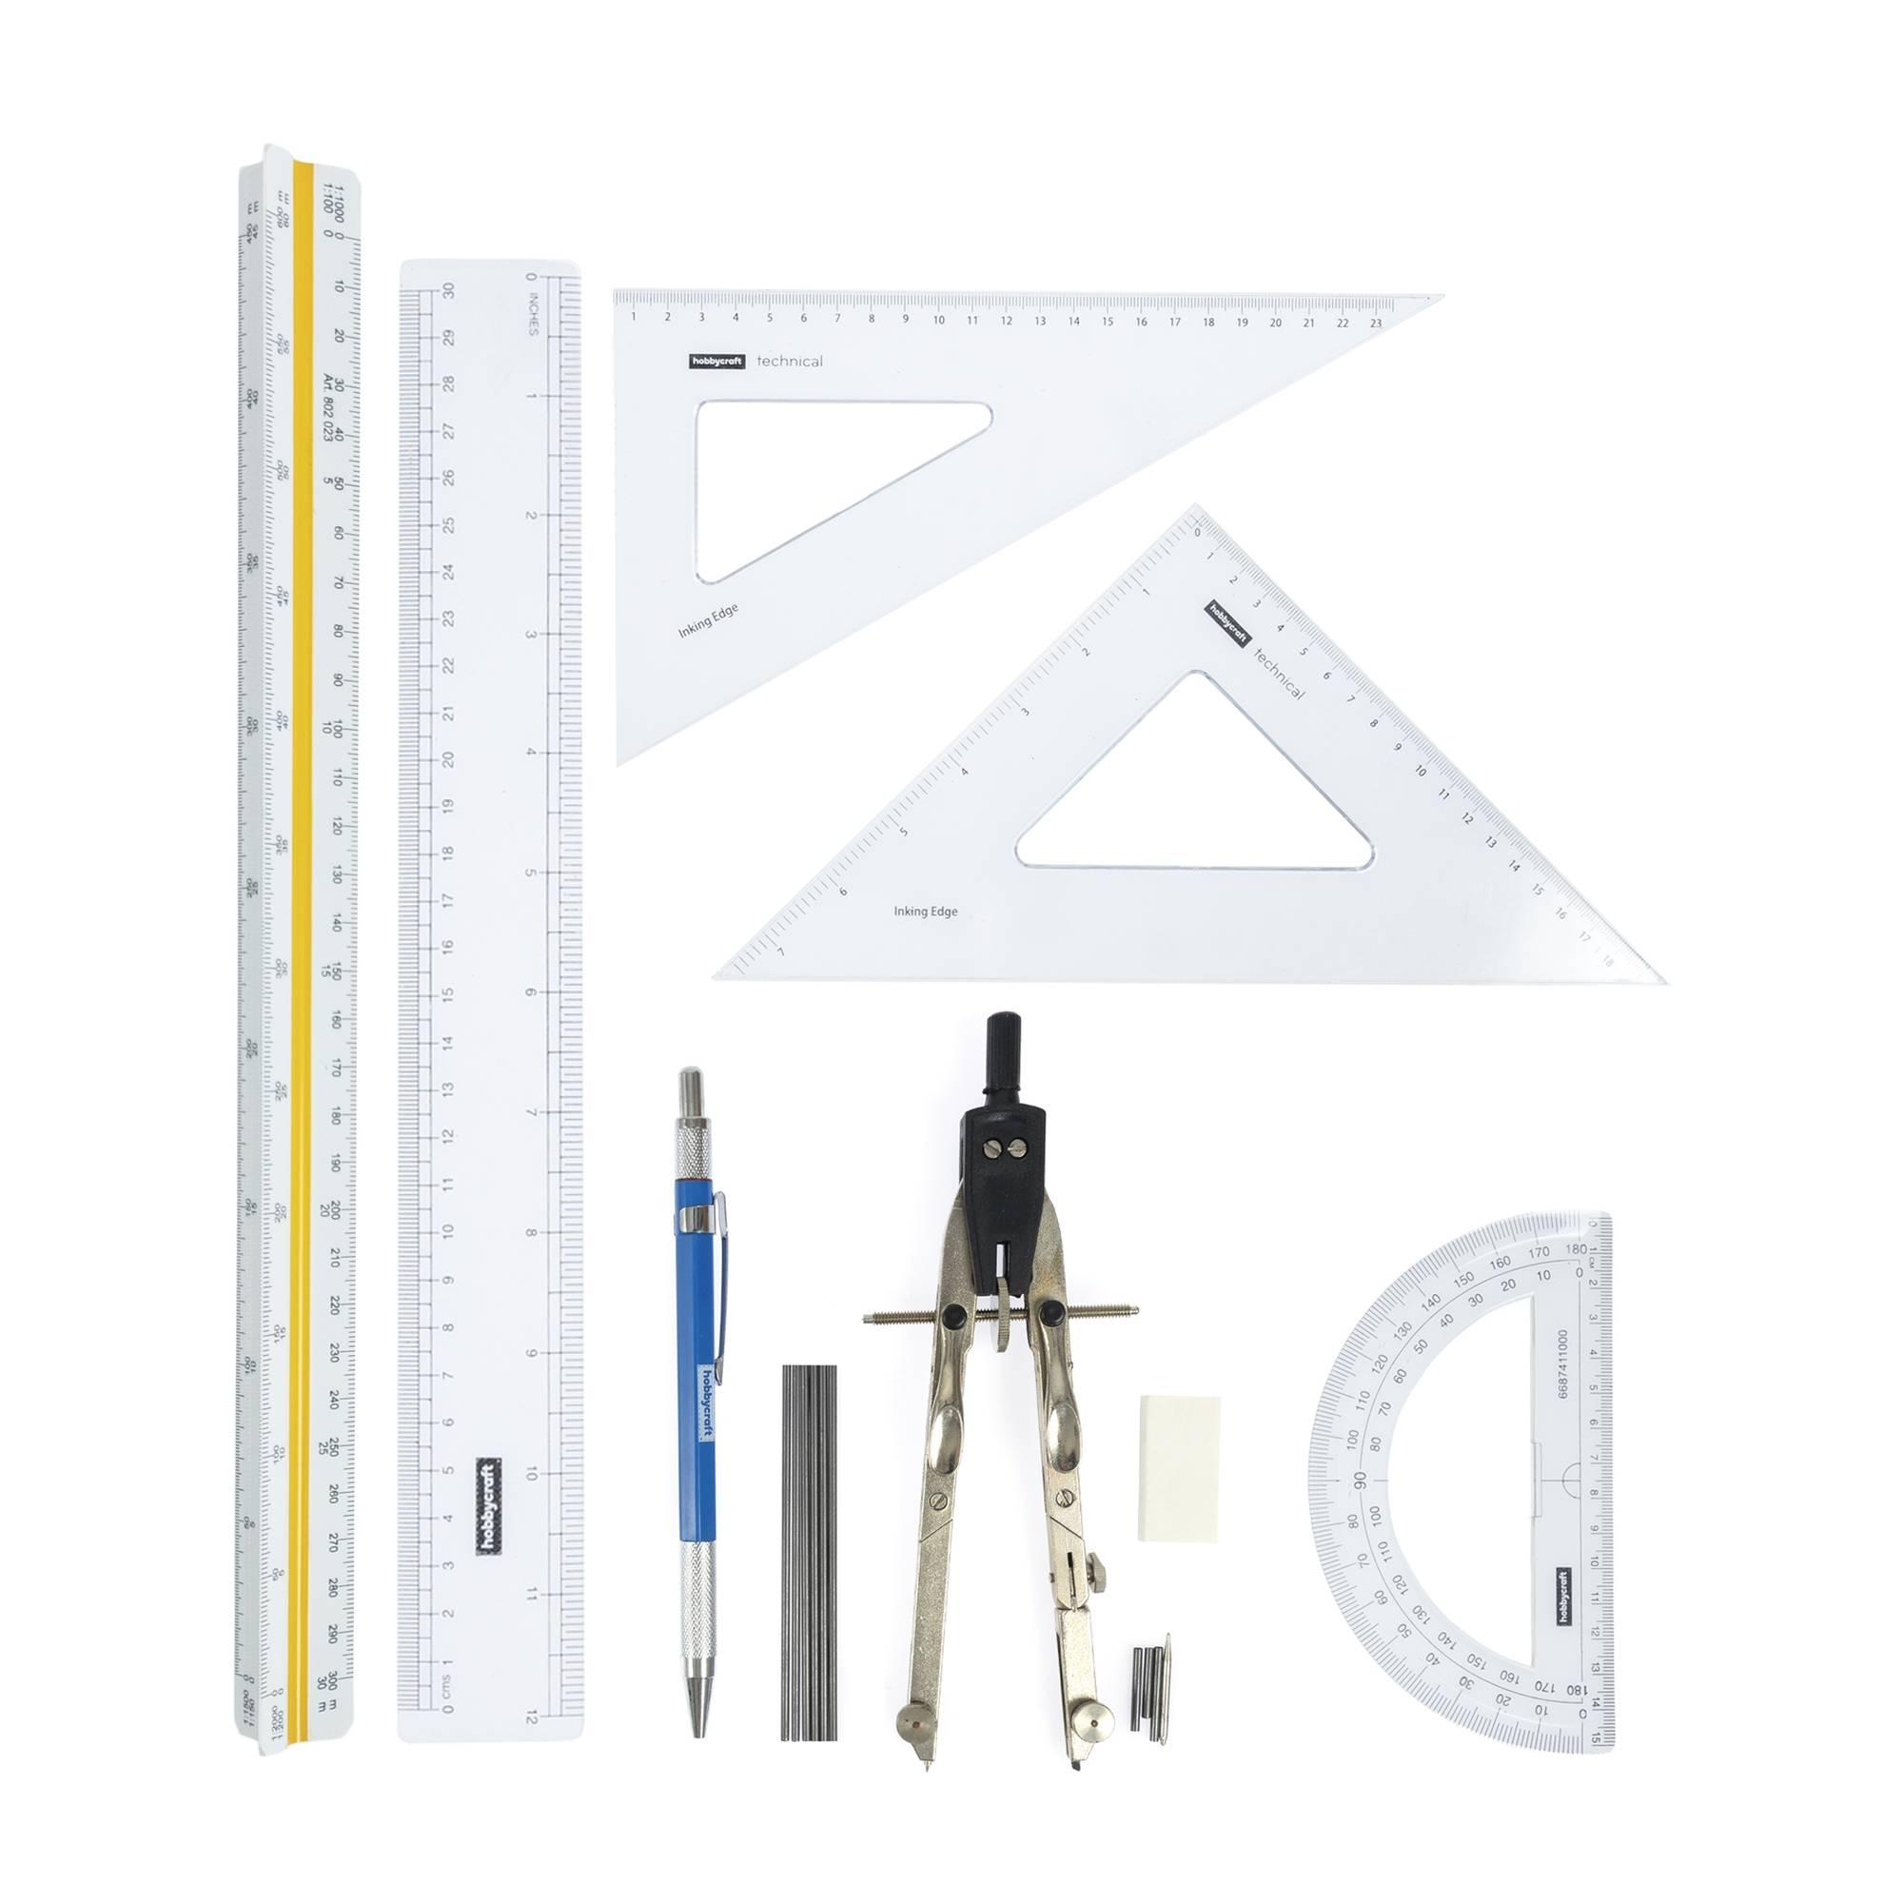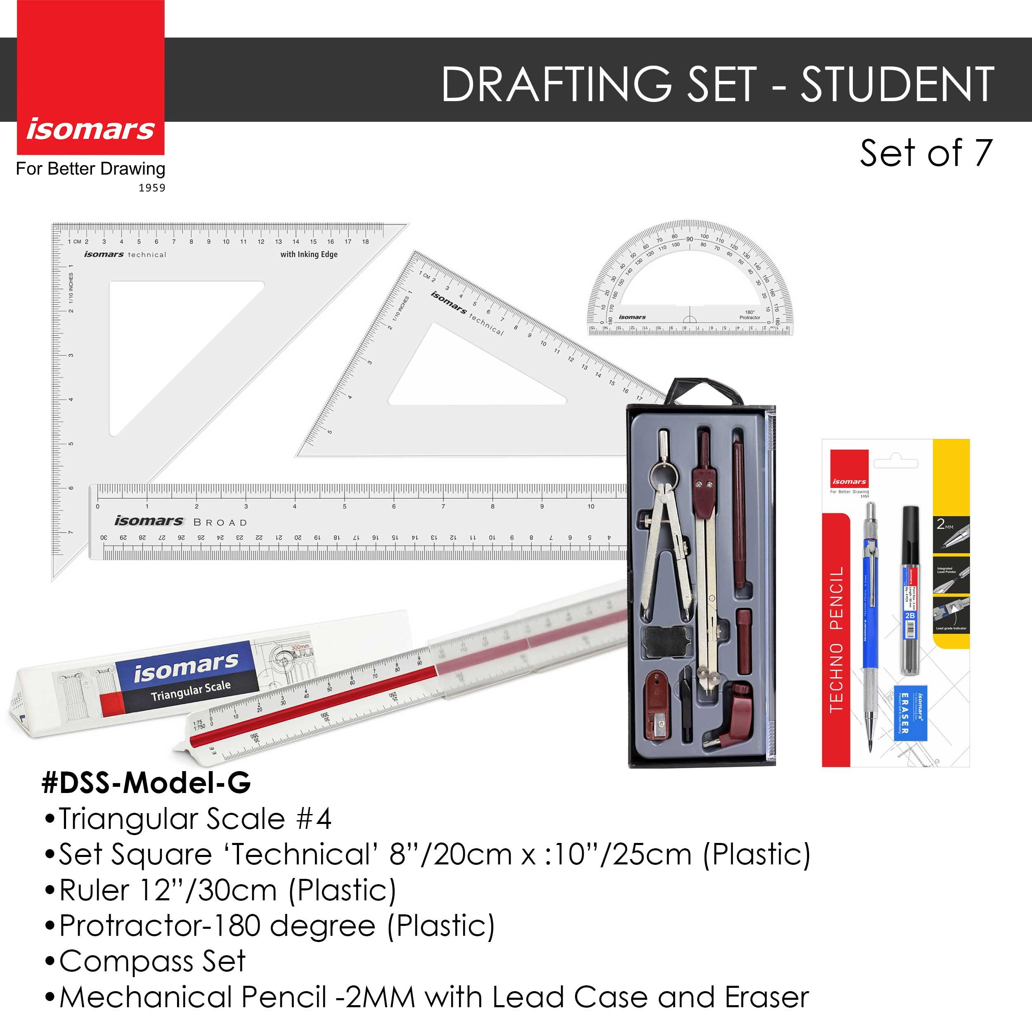
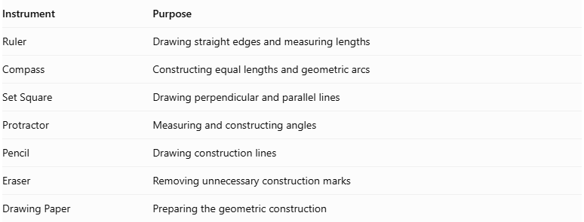
Instrument | Purpose
Ruler | Drawing straight edges and measuring lengths
Compass | Constructing equal lengths and geometric arcs
Set Square | Drawing perpendicular and parallel lines
Protractor | Measuring and constructing angles
Pencil | Drawing construction lines
Eraser | Removing unnecessary construction marks
Drawing Paper | Preparing the geometric construction
Construction Method: Instrument-Based

Construction Procedures

Constructing the Trapezoidal Base
# Source: AI Source: Provided by: [Data Path: Persons Table -> ID Column: 1, Name_En Column: Motasem Essam] -> From: [ChatGPT] on [7/25/2026]
- Draw a straight line representing the longer parallel side of the trapezoid.
- Construct a second parallel line at the desired distance using a ruler and set square.
- Mark the required shorter parallel side on the second line.
- Construct the two non-parallel sides by connecting the corresponding endpoints.
- Verify that the two designated base sides are parallel.
- Label the four vertices.

Constructing a Right Trapezoidal-Base Pyramid
# Source: AI Source: Provided by: [Data Path: Persons Table -> ID Column: 1, Name_En Column: Motasem Essam] -> From: [ChatGPT] on [7/25/2026]
- Construct the trapezoidal base.
- Draw the diagonals of the trapezoid to locate their intersection.
- Draw a perpendicular line through this intersection.
- Mark the desired perpendicular height on the line.
- Label the endpoint as the apex.
- Connect the apex to all four base vertices.
- Draw visible edges using solid lines.
- Draw hidden edges using dashed lines where appropriate.
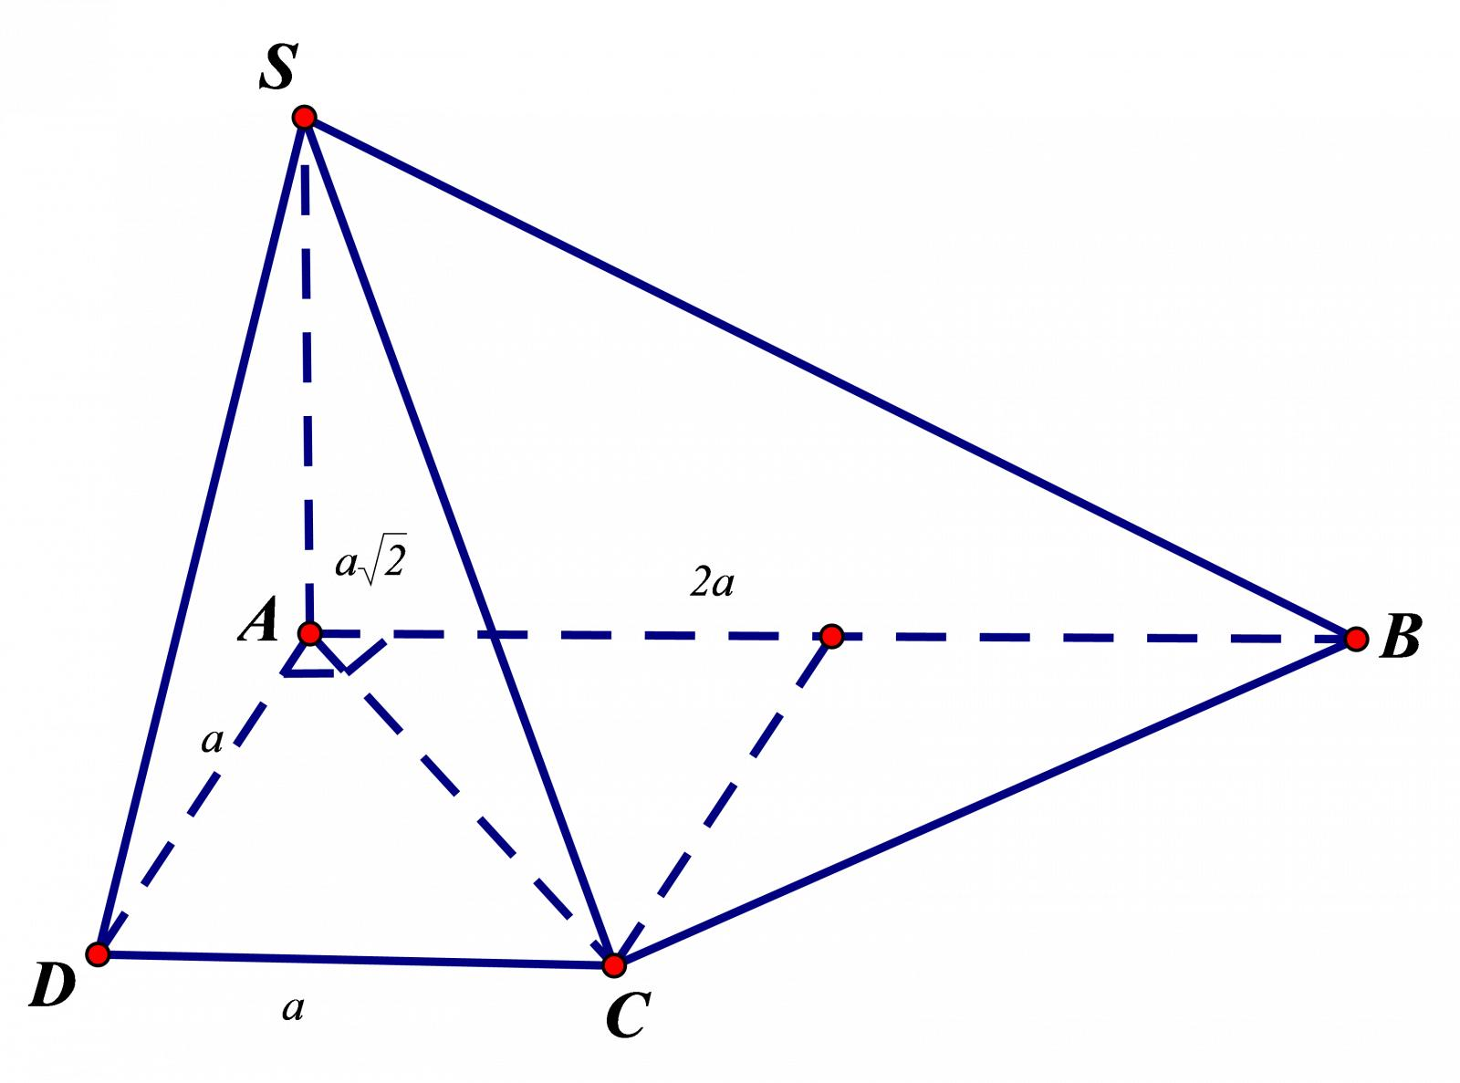
Note: The intersection of a trapezoid's diagonals is not generally its geometric center. A pyramid with its apex directly above that intersection is not necessarily symmetric.

Constructing an Oblique Trapezoidal-Base Pyramid
# Source: AI Source: Provided by: [Data Path: Persons Table -> ID Column: 1, Name_En Column: Motasem Essam] -> From: [ChatGPT] on [7/25/2026]
- Construct the trapezoidal base.
- Select an apex position that is not directly above the intersection of the base diagonals.
- Draw the apex above the base plane.
- Connect the apex to all four base vertices.
- Distinguish visible and hidden edges.
- Verify that all four lateral faces are triangular.

Constructing the Net of a Trapezoidal-Base Pyramid
# Source: AI Source: Provided by: [Data Path: Persons Table -> ID Column: 1, Name_En Column: Motasem Essam] -> From: [ChatGPT] on [7/25/2026]
- Draw a trapezoid representing the base.
- Construct four triangular faces, one attached to each side of the trapezoid.
- Determine the dimensions of each triangle using the corresponding lateral edges.
- Add joining flaps if the net is intended for physical assembly.
- Cut and fold the net to form the pyramid.
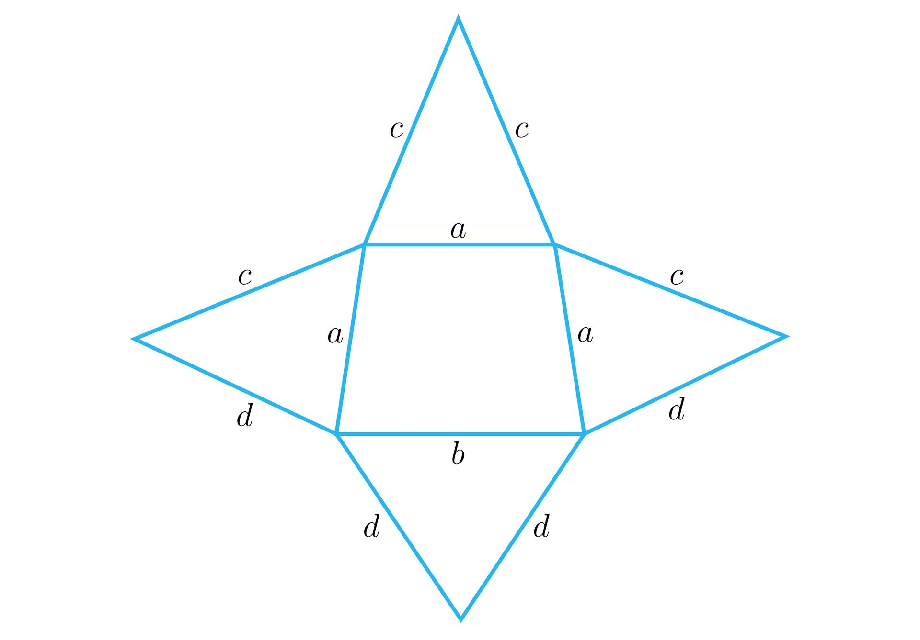

Applications
# Source: AI Source: Provided by: [Data Path: Persons Table -> ID Column: 1, Name_En Column: Motasem Essam] -> From: [ChatGPT] on [7/25/2026]
Trapezoidal-base pyramids can be used in:
- Architecture: Conceptualizing structures with sloping triangular sides and trapezoidal footprints.
- Engineering: Modeling tapered components and geometric solids.
- 3D modeling: Creating polyhedral shapes in CAD software and computer graphics.
- Geometry education: Understanding quadrilaterals, triangular faces, surface area, and volume.
- Fabrication: Estimating material requirements when producing a solid or a hollow shell with this geometry.

Key Points
# Source: AI Source: Provided by: [Data Path: Persons Table -> ID Column: 1, Name_En Column: Motasem Essam] -> From: [ChatGPT] on [7/25/2026]
- A trapezoidal-base pyramid has a trapezoid as its base.
- It has four triangular lateral faces.
- It contains 5 faces, 8 edges, and 5 vertices.
- The base area is $B=\frac{1}{2}\left(a+b\right)h_{b}$.
- The volume is $V=\frac{1}{3}BH$.
- The lateral surface area is the sum of the four triangular face areas.
- The height of the pyramid is perpendicular to the base plane.
- The trapezoid's height and the pyramid's height are different measurements.
- The definition of a trapezoid varies between inclusive and exclusive classification conventions.

Conclusion
# Source: AI Source: Provided by: [Data Path: Persons Table -> ID Column: 1, Name_En Column: Motasem Essam] -> From: [ChatGPT] on [7/25/2026]
A trapezoidal-base pyramid is a polyhedron formed by a trapezoid base and four triangular lateral faces meeting at one apex. Like every quadrilateral pyramid, it has five faces, eight edges, and five vertices.
Its distinctive feature is its trapezoidal base, which has at least one pair of parallel sides under the inclusive convention. The base area is calculated using the parallel sides and the perpendicular distance between them, while the volume is one-third of the base area multiplied by the pyramid's perpendicular height. Surface area calculations require the areas of the individual triangular faces.

